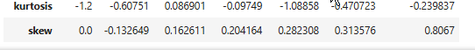
Skewness And kurtosis

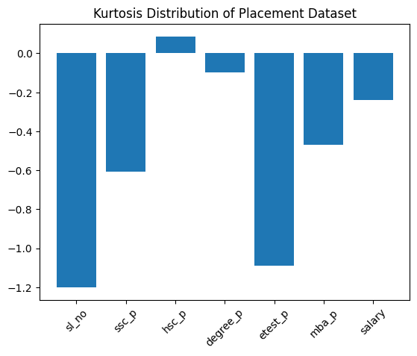
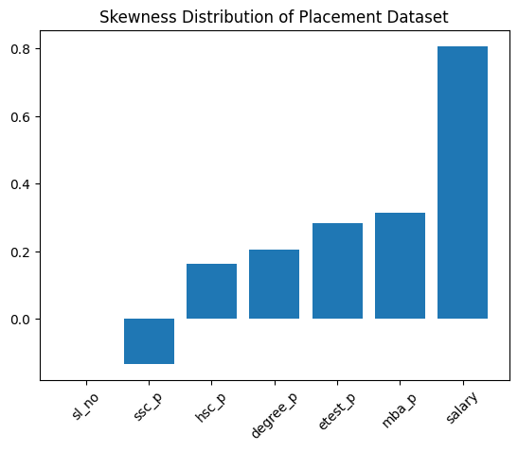

Kurtosis Bar Chart:
“This chart shows how peaked or flat each variable is Negative kurtosis indicates flat distributions, meaning values are more spread out and there are fewer extreme outliers Most academic scores show light-tailed behaviour, which indicates consistency among students.

Skewness Bar Chart:
This chart explains data symmetry. Most features are slightly right-skewed, indicating more students score around the average with fewer high values. Salary has strong right skewness, meaning a small number of students receive very high salary packages.
Summary:
The placement dataset shows nearly symmetric distributions for academic scores indicating consistent student performance. Salary data is positively skewed reflecting that only a few students receive high salary packages. Kurtosis values suggest flat distributions with minimal extreme outliers making the dataset suitable for statistical modelling and machine learning after minor transformations if required.

